Hello Everyone,

The incredible advancements in computer graphics and how they have transformed modern entertainment are especially clear when considering how realistic rendering, virtual worlds, and character modeling have improved over time. In recent years, these technologies have become so sophisticated that some imagery in animations and video games appear nearly indistinguishable from photography. The level of detail that modern rendering techniques can achieve creates realistic and immersive experiences that uniquely impact the people that view them.

Modern video game graphics are perhaps the greatest example of how realistic rendering and virtual worlds enhance storytelling and user engagement. Having grown up playing video games, I would never have imagined the kind of environments that modern game engines can now create. With high-resolution monitors boasting refresh rates of 144Hz or even higher, the player can feel fully immersed in another world. To put into perspective how incredible this kind of image processing is, refreshing an image with 2560x1440 resolution 144 times per second equates to over 530-million pixel updates per second.

**Figure 1**

*Modern Video Game Graphics*

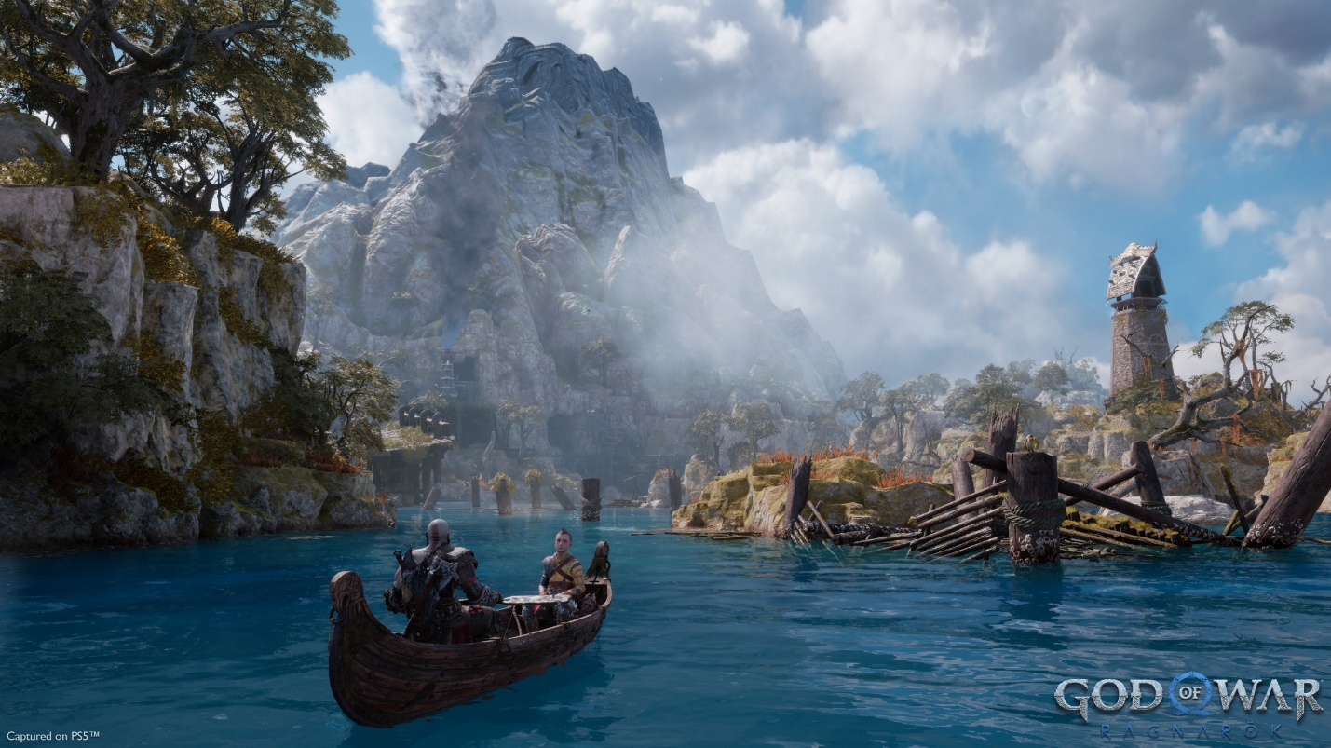

*Note.* Adapted from “God of War Ragnarök,” by D. Coldewey, 2022, *Review: God of War Ragnarök* (<https://techcrunch.com/2022/11/03/review-god-of-war-ragnarok/>). Copyright 2024 Yahoo.

Beyond just the image quality, different advanced rendering and animation techniques help environments and characters to feel realistic. For example, many modern games have detailed graphics settings that allow users to strike a balance between visual quality and performance (less computationally heavy graphics settings will run faster). One such option is anisotropic filtering, which modifies textures viewed from oblique angles in order to mitigate the blurring effect of lower quality textures used for objects at a distance (Intel, n.d.). A rendering technique like this may only have a small impact on its own, but dozens of these techniques combined can create photo-realistic imagery. Regarding animation, one interesting method to discuss is inverse kinematics, which is a way of mathematically calculating the natural position and angle of joints based on the coordinates of the endpoint (Bermudez, 2017). To give a concrete example, many video games use this technique to determine how to position a character’s knee joints when placing their feet on different elevation levels, such as different steps of a staircase. Utilizing this technique creates a much more realistic effect than simply allowing the character’s feet to hover unnaturally.

Speaking of characters, animation techniques such as motion capture (and more broadly, performance capture) have been creating many memorable movie characters for years now, and more recently creating memorable video game characters as well. The CGI techniques developed by Weta FX in New Zealand have allowed for characters such as Gollum in *the Lord of the Rings* and Thanos in *Avengers: Infinity War* to appear in scenes alongside real actors without feeling uncanny to the viewer (Gilmore, 2023). In fact, these characters capture human emotions through careful mapping of an actor’s facial movements so well that it can be difficult not to sympathize with them (although perhaps villains such as Gollum or Thanos are not the best examples of this). By translating real movements into animations, storytellers can create incredibly compelling and engaging characters that stick with viewers for years to come.

References:

Bermudez, L. (2017, July 10). *Overview of Inverse Kinematics*. Medium. <https://medium.com/unity3danimation/overview-of-inverse-kinematics-9769a43ba956>

Gilmore, S. V. (2023). *Gollum, Caesar, Thanos: The Algorithmic Body Across Twenty Years of Motion Capture*. Senses of Cinema. <https://www.sensesofcinema.com/2023/the-geometry-of-movement-computer-generated-imagery-in-film/gollum-caesar-thanos-the-algorithmic-body-across-twenty-years-of-motion-capture/>

Intel. (n.d.). *What Is Anisotropic Filtering?* <https://www.intel.com/content/www/us/en/gaming/resources/what-is-anisotropic-filtering.html#:~:text=Anisotropic%20filtering%20makes%20distant%20objects,only%20a%20small%20performance%20impact>.